**Management Plan: Sprint #0**

**Gnatt Chart:**

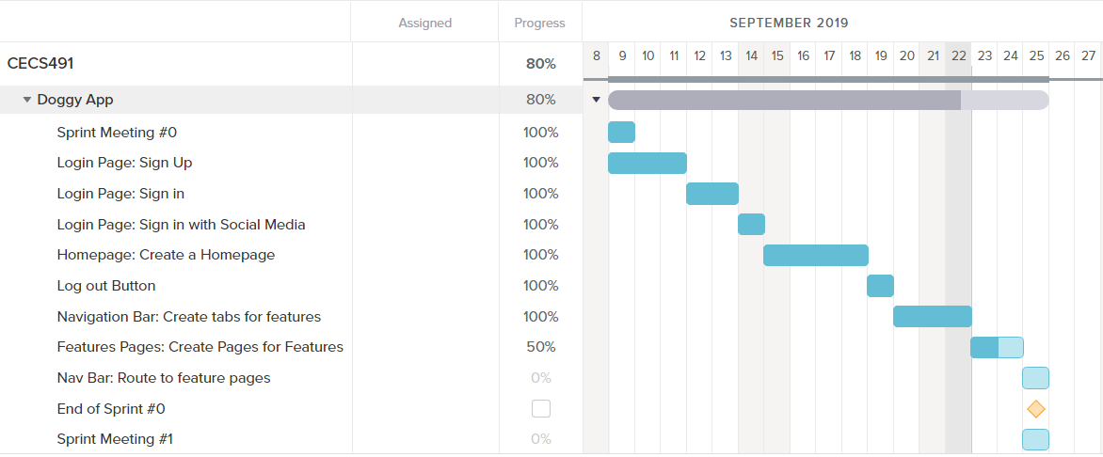

In this sprint, we started working on the login page and home page of our web application.

**Code Development velocity calculation:**

In this sprint, we had planned to finish 28 points worth tasks and we were able to finish it on time. Therefore, our code development velocity is about 30 points per sprint.

**Sprint Retrospective:**We discussed the teams’ purpose and deliberately decided on what we would work on individually during the sprint. We determined our priorities for the assigned jobs. We discussed what went well and what needs improvement alongside the aspects of the development which were done.